Experiment No:3 Energy and Power Analysis of Signals
Objective:
(i) To calculate the energy and average power of given continuous-time and discrete time signals and classify them as energy signals, power signals, or neither based on their energy and power characteristics.
Procedure:
1. Define the time vector and generate the selected signals.
2. Compute the squared magnitude of each signal.
3. Numerically integrate over a sufficiently large interval for energy. 4. Compute average power over an interval containing several periods for the periodic signal.
5. Compare numerical results with analytical expectations.
6. Classify the signals and record observations.
Matlab Coding:
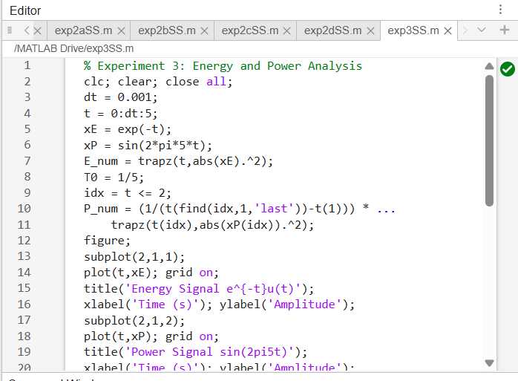

Output:
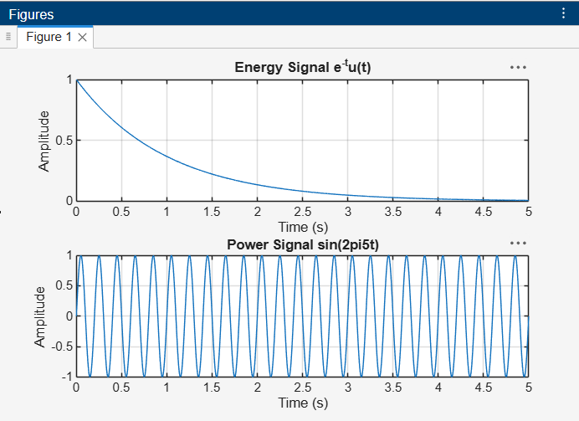
Result:
The numerical energy of x₁(t) = e^(−t) u(t) is approximately 0.5000, and the numerical average power of x₂(t) = sin(2π5t) is approximately 0.5000. The results agree with the theoretical values within the expected numerical accuracy.

